You should also be aware, that not all people are eligible to be a Trustee. Under section 69 of the Charities & Investment [Scotland] Act 2005, the following are disqualified from acting as charity trustees:

• Someone with an unspent conviction for dishonesty or an offence under the Act
• An un-discharged bankrupt
• Someone who has been removed under either Scottish or English Law or the courts, from being a charity trustee
• A person disqualified from being a company director

We hope that the information has given you a brief overview of what it means to be a charity trustee.

If you have any questions, or wish to please learn more about the application process for joining our board of trustees, please contact:

Manager
Mary Wilson, Senior Co-ordinator

Or

Chairperson
Sheena Ingham, Interim Chairperson

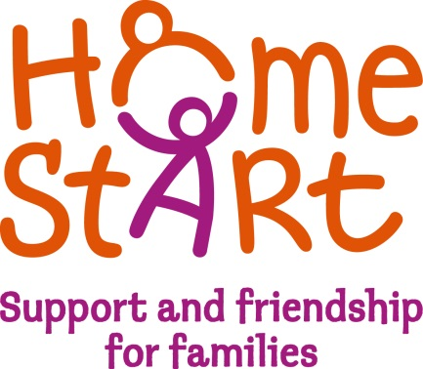

BECOMING
A
CHARITY TRUSTEE
FOR

HOME-START WIGTOWNSHIRE

WHAT is a Charity Trustee?

The people who make up the governing body of a Scottish charity, often called a board or a committee, are defined by the Trustee and Investment [Scotland] Act 2005, as being a “charity trustee”.

These Trustees have a responsibility to ensure that the activities of the charity are carried out in accordance with requirements of the governing document and the 2005 Act.

WHAT
Home-Start Wigtownshire is a charitable company and is governed by a board of trustees, who have responsibility for its governance, strategic direction and development.

THIS MEANS THAT
The trustees have to ensure that the organisation complies with requirements under both Charity and Company Laws, in addition to other laws such as Employment, Health & Safety etc.

WHAT
Business meetings are held every 6 weeks when discussions and decisions are taken on strategic matters. In addition, there is a sub-finance committee.

THIS MEANS THAT
Trustees are expected to attend every meeting, and take an active part in the discussions and decision-making. You may also be asked to be part of a sub-group.

WHAT
Occasionally there will be items on the agenda, which are sensitive, confidential or are not yet public knowledge.

THIS MEANS THAT
They must not be discussed outwith the meeting, or with other people not connected with your Home-Start.

WHAT
Occasionally there are items on the agenda, where the decisions would give you a personal advantage or may conflict with the interests of another organisation you may be involved with.

THIS MEANS THAT
As a trustee of Home-Start Wigtownshire you must declare a ‘conflict of interest’ and take no part in the discussions.

WHAT
The trustees are responsible for ensuring that there is sufficient funding available to carry out the work of the charity: accountable for how it is spent and to ensure that proper accounting records are set up and maintained.

THIS MEANS THAT
Budgets and financial reports will be presented at trustee meetings and you will be expected to have an overview of the financial processes: ask questions when you are unsure.

WHAT
The effectiveness of the trustees is enhanced when all members are working together from the beginning.

Trustees are expected to use their current skills or experience in their role as a trustee, and to keep up to date with new legislation or current trends.

THIS MEANS THAT
All new trustees are expected to complete an induction programme and you will be expected to attend other training throughout the year.

This will help members to get to know each other better, and to work more effectively as a team.

WHAT
Home-Start Wigtownshire employs staff members who take care of the operational side of the charity, developing and supporting the services.

THIS MEANS THAT
The trustees have employment responsibilities, which require them to have some basic understanding of being an employer, especially in the direction, support and development of the staff team. They should know where their responsibilities lie, which areas are delegated to the staff, and ensure that the boundaries are respected.

